**LITERATURE SURVEY**

|  |  |
| --- | --- |
| **Date** | 10 September 2022 |
| **Team Id** | PNT2022TMID46996 |
| **Project Name** | Project-5917-1658819801 |
| **Maximum Marks** | 4 Marks |

**1.ABSTRACT:**

Crude oil is the "key" commodity for the global economy as it is the most significant strategic resource on the planet. As a result, forecasting it has been difficult because many different factors affect its price, making it difficult to predict. The price of crude oil is highly volatile and erratic. Numerous research have recently been conducted in an effort to analyse the difficulty of predicting oil prices and find the best solutions. It will be beneficial for our government, businesses, and investors to anticipate its demands. As part of this research, artificial neural networks (ANNs) will be built to forecast crude oil prices. In this study, we suggest a cutting edge method for predicting the price of crude oil using analytical. Keywords: Crude oil, economy, energy, fuel, price.

**2.LITERATURE SURVEY:**

**2.1 Application of Traditional and Statistical Econometric Models:**

Academic academics are starting to use the usual statistical and econometric approaches among the many and various forecasting models that have been created to anticipate the price of "black gold." Amano offers the first study on oil market forecasts (1987). To forecast the oil market, the author employed a small-scale econometric model. Huntington (1994) used an advanced econometric model to forecast the price of oil in the 1980s. Gulen (1998) used co-integration analysis in a different study to forecast the price of WTI crude oil. To predict the price of oil, Barone-adesi et al. (1998) proposed a semi-parametric approach based on the filtered historical simulation technique. Morana (2001) used a semi-parametric technique based on the GARCH features of the volatility of oil prices, which were studied by Barone-adesi et al (1998) suggested a semi-parametric approach based on the filtered historical simulation technique to forecast oil price. Based on the GARCH properties of the oil price volatility, Morana (2001) employed a semi-parametric approach investigated by Barone-adesi et al. (1998) to short-term forecast of Brent crude oil price. In another work, Tang and Hammoudeh (2002) utilized a nonlinear regression to predict OPEC basket price. Using OECD petroleum inventory levels and relative stock inventories, Ye et al. (2002, 2005) adopted a simple linear regression model for short-term monthly prediction of WTI crude oil spot price. In a related study, Ye et al. (2006) included nonlinear variables such as low- and high- inventory variables to the linear forecasting model suggested by Ye et al. (2002, 2005) to predict short-run WTI crude oil prices. Zamani (2004) used an econometrics forecasting model to anticipate the short-term quarterly WTI crude oil spot price using OECD stocks, non-OECD demand, and OPEC supply. Using error correction models, Lanza et al. (2005) looked at the pricing of products and crude oil. Sadorsky (2006) used GARCH, TGARCH, AR, and BIGARCH statistical models, among others, to forecast daily volatility in petroleum futures price returns. To predict oil demand, supply, and prices, Dees et al. (2007) created a linear model of the global oil market with a primary focus on OPEC behaviour. Murat and Tokat (2009) looked into the connection between futures and spot crude oil prices and used the random walk model to test if futures prices might predict changes in spot prices.

However, more recent research have used GARCH and several models from the GARCH family to forecast oil prices. For instance, the GARCH model was employed by Narayan and Narayan (2007) and Agnolucci (2009) to forecast spot and futures crude oil prices. In a related study, Mohammadi and Su (2010) investigated the crude oil price predicting outcomes of various GARCH-type models. CGARCH, FIGARCH, and IGARCH models were suggested by Kang et al. (2009) to predict the volatility of crude oil markets.

Wei et al. (2010) enhanced the work of Kang et al. (2009) towards the same goal by using linear and nonlinear GARCH-class models. As a result of the application of linear techniques, a sizable difference between the projected and real price of oil has been demonstrated. The most often utilised exogenous variables in these models for predicting oil prices are inventories, supply, and demand. The fact that supply and demand are relatively inelastic to price changes and that inventory adjustments can take time to materialise account for a considerable share of the difference between actual and predicted prices, especially in the near run (Hamilton, 2008). However, traditional statistical and economic techniques frequently only detect linear processes in data. data time series. (Weigend and Gershenfeld, 1994). However, the oil prices behavior is characterized by a high nonlinearity and irregularity. Therefore, the mentioned models are not the appropriate choice to forecast the oil price.

**2.2 Artificial Neural Network (ANN):**

**2.2.1 Definition and Neuron Model Evolution**

**2.2.1.1 Definition**

ANN is an input-output mathematical model that mimics how the human brain functions by adopting the same strategy for learning new things. An equivalence between a biological and an artificial neuron is shown in Fig. 1.

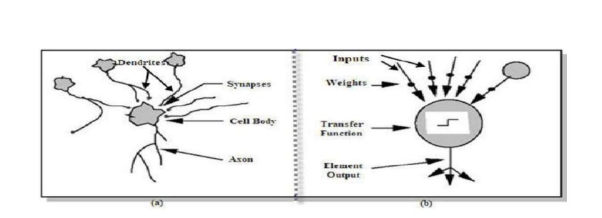

**model Figure 1. Analogy between biological neuron (a) and artificial neuron (b)**

**2.2.1.2 Neuron Model Evolution**

**a) McCulloch & Pitts (1943) neuron model**

McCulloch & Pitts (1943) neuron model McCulloch and Pitts (1943) proposed the first artificial neuron also called formal neuron. Mathematically, the McCulloch written as follows:

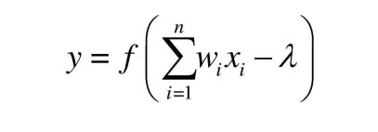

Where 1 2 x , x , ..., n x represent the McCulloch- Pitts neuron inputs that are exclusively binary values (zeros or ones), 1 2 , ,..., w w wn are the connections‟ weights received by the neuron. f is the sign function, λ is the threshold and y is the output of McCulloch -Pitts neuron defined as:

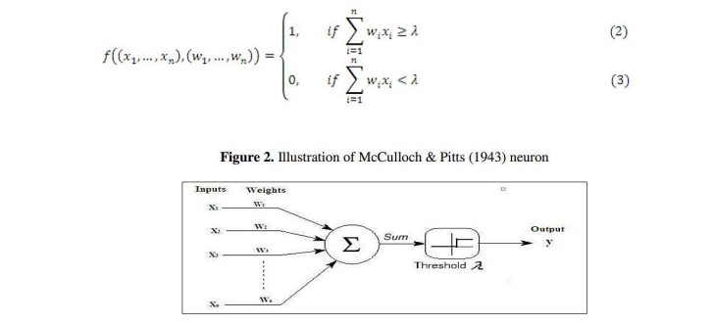

**b) Multilayer perceptron model**

Without hidden layers, perceptron neural networks assume just binary input-output values and only two layers, which explains why the model can only handle linearly separable functions. The delta rule was developed by Windrow and Hoff in 1960 and consists of changing the weights of the connections to minimise the discrepancy between the desired and actual output value. As a result, in place of 0 and 1, the output value can take any value. In their book, Minsky and Papert (1969), emphasised the value of including one or more hidden layers to identify the intricate features contained in the inputs. Traditionally, the multilayer perceptron net was trained using Rumelhart et albackpropagation .'s learning technique (explained in more depth in the following section) (1986).The multilayer perceptron is composed of a layer of input units, one or more hidden layers and an output layer (see Fig .4).

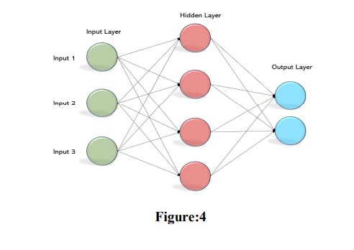

In this network system, the information propagates in a single direction „„forward‟‟: the input units pass the information to the neurons in the first hidden layer, the outputs from the first hidden layer are subsequently

passed to the next layer, and so forth. Thus, the network output (for example, with one hidden layer) is:

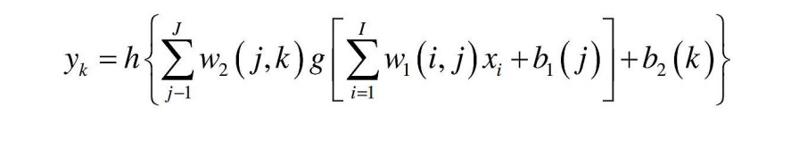

Where: i x are the input variables of the network; I is the number of input variables; J is the total number of nodes in the hidden layer; K is the number of neurons in the output layer; g and h are, respectively, the transfer/activation function of the first and the second layer; w1 is the weights matrix of the hidden layer; w2 is the weights matrix of the output layer; 1 b and 2 b are the bias vectors of the hidden layer and of the output layer, respectively. To note, at least one transfer function (see the next section for more description of transfer function) of the hidden layer must be nonlinear (Hornik et al., 1989).

**References:**

[1] Yu Runfang, Du Jiangze and Liu Xiaotao, “Improved Forecast Ability of Oil Market Volatility Based on combined Markov Switching and GARCH-class Model, Procedia Computer Science, vol. 122, pp. 415-422, 2017.

[2] K. Greff, R. K. Srivastava, J. Koutník, B. R. Steunebrink and J. Schmidhuber, "LSTM: A Search Space Odyssey," IEEE Transactions on Neural Networks and Learning Systems, vol. 28, no. 10, pp. 2222-2232, Oct. 2017.

[3] Mohammad Reza Mahdiani and Ehsan Khamehchi, “A modified neural network model for predicting the crude oil price”, Intellectual Economics, vol. 10, no. 2, pp. 71-77, Aug. 2016.

[4] Manel Hamdi and Chaker Aloui, "Forecasting Crude Oil Price Using Artificial Neural Networks: A Literature Survey," Economics Bulletin, AccessEcon, vol. 35, no. 2, pp. 1339-1359, 2015.

[5] Aloui, Chaker & Hamdi, Manel. (2015). Forecasting Crude Oil Price Using Artificial Neural Networks: A Literature Survey. Economics Bulletin. 35. 1339-1359.